ARTH 345 Spring 2021
Final exam
Due: Thursday, May 6, 11:59 pm
Submission:
- Please type and save your document in Microsoft Word, rtf (you can type directly onto the Word version of the test if you wish), or PDF.
- Go to Blackboard.
- Click on “Assessments” on the menu on the left.
- Click on “Final exam” folder.
- Click on “ARTH 345 final exam” assignment and follow the instructions to upload your document.

Please complete all 4 parts for full credit
Part 1. Short answer questions related to Hendrik Goltzius, Farnese Hercules, 1592.
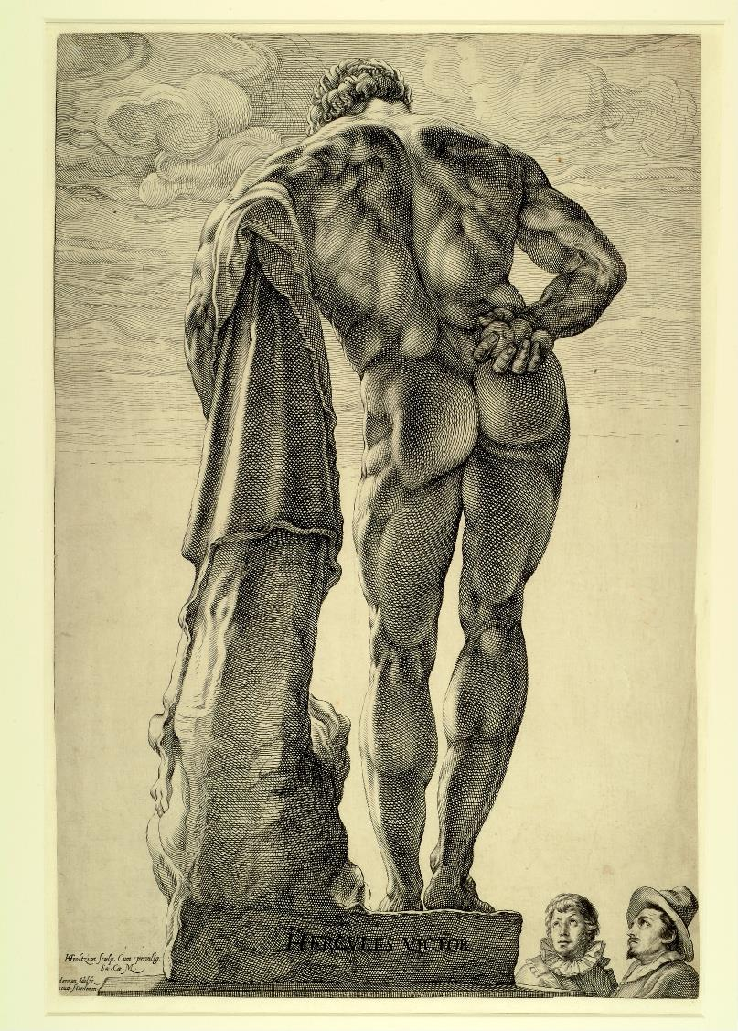
Question 1 (5 points)
Briefly explain the process by which Goltzius produced this image. What materials, tools, and equipment were involved? (4 or 5 sentences)

Question 2 (2 points)
How does Goltzius create tonal variations (levels of shading) in this image? (2 or 3 sentences)

Part 2. One single-image essay questions (20 points). Your answer should be about 150 – 200 words in length.
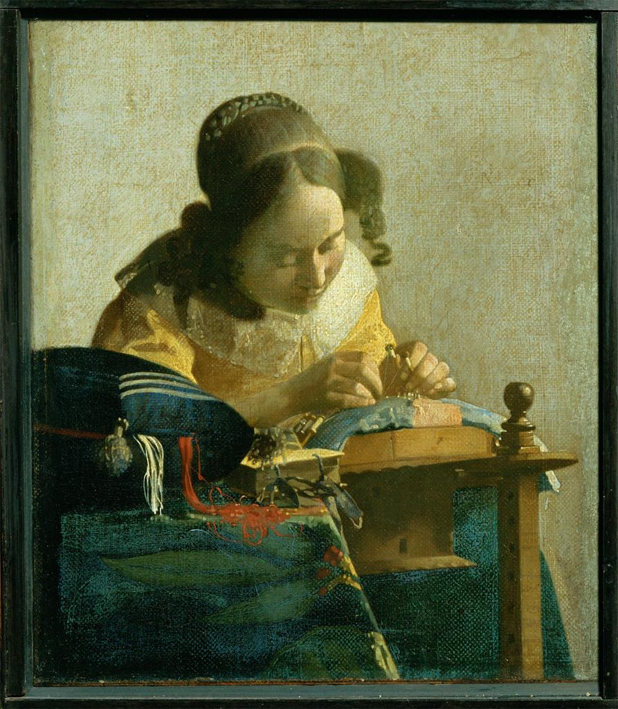
Johannes Vermeer, The Lacemaker, c. 1669

While the subject of this painting was conventional in Dutch genre painting, its formal qualities were less so. Discuss the unusual visual effects and their possible connections to new visual technology in Delft at the time.

Part 3. One comparison between two images (40 points). Your answer should be about 300 – 350 words.

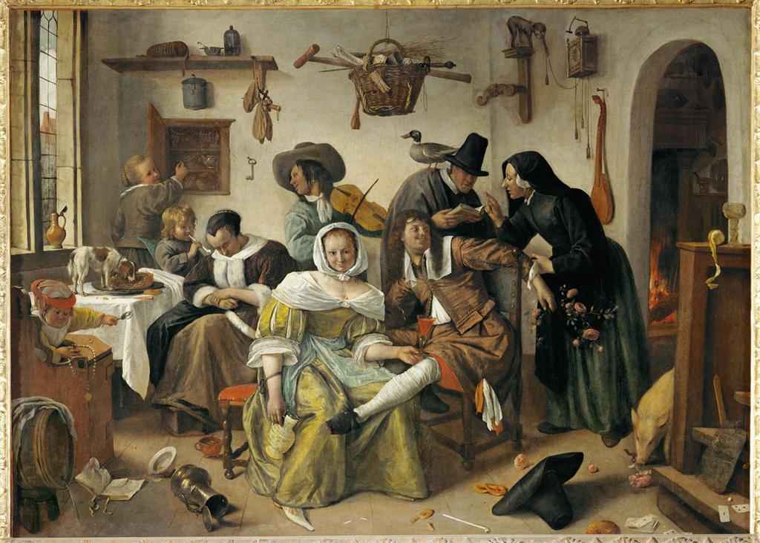
Jan Steen, In Luxury, Look Out, 1663

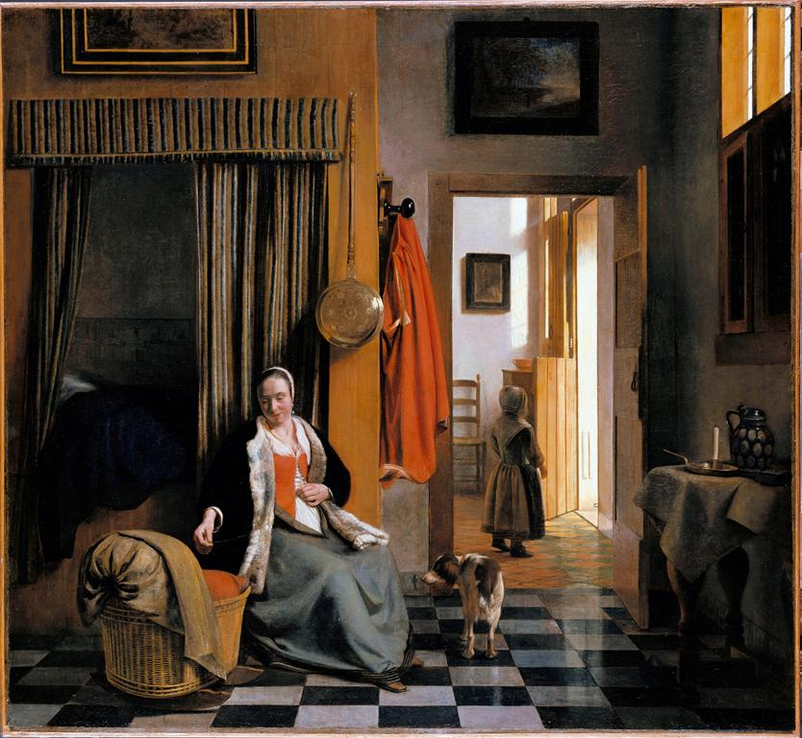
Pieter de Hooch, The Mother, c. 1670
As the videos for Module 11 explain, the home was a crucial concept in Dutch moral ideology. Moralists also believed that different kinds of women could uphold or threaten the sanctity of the home. How do these two paintings address those beliefs?

Part 4. “Unknown” image (10 points). Your answer should be about 80 – 100 words.

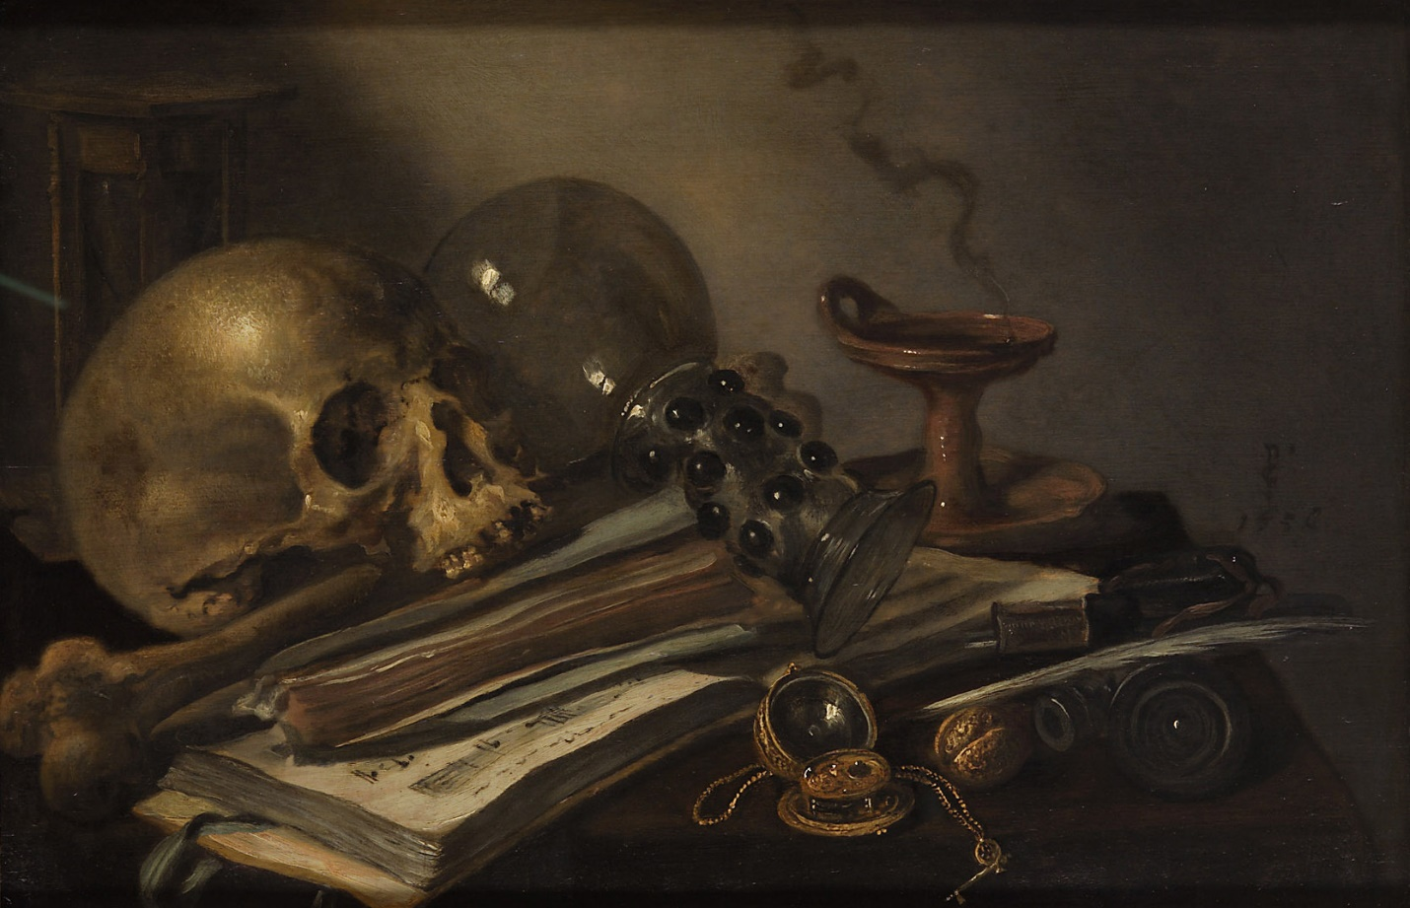

This painting was not covered in class, but does it look similar to any works you saw in the videos for Module 12? What moral messages might it have conveyed to the 17th-century viewer and how?

